**Top 10 car racing games:**

Racing is a fascinating gaming genre to attract millions of gamers across the globe. With some amazing consoles and quality interface, racing games provide exciting and adventurous experiences to the Gamers. These are the competitive genres and have various options and advantages with the rewards they provide. Apart from that, with the help of multiplayer features, this gaming acquires a higher fan base with the competitive nature that it offers. Multiplayer racing games offer a sense of speed embedded in the gaming technique.

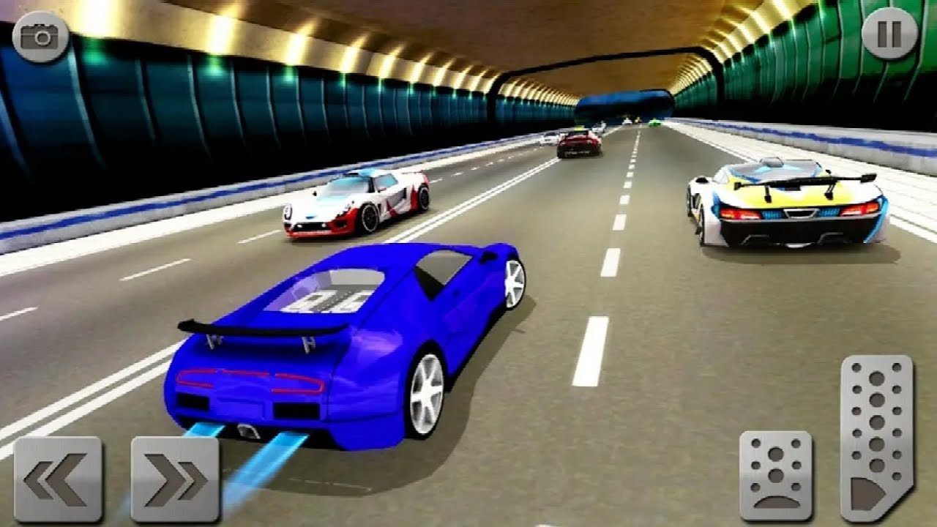

There are several racing games available for various devices, and some also work on the consoles. Racing games are there for PC and mobile devices both. Racing games are available featuring various vehicles also. Here is a list of top 10 car racing games for mobile devices:

**Asphalt 8: Airborne**

Asphalt 8 is available on Android and iOS, as well as Windows phones. This is the longest mobile racing franchise that established in the world and it first existed only for PC before the Android and IOS versions. Airborne, Asphalt 8 is a great version that has many cars to be unlocked and has multiplayer racing features available for online gameplay with an appealing interference.

**Asphalt 9 Legends**

Asphalt 9 is there that is available from Gameloft and is the latest one in the franchise. This is a racing game with excellent graphics and console features available and has various content for gameplay. There are more than 800 events including both the monthly and weekly ones and PVP action is also there. Asphalt 9 has more than 50 cars and racing tracks that are available for unlock and it is a premium style gaming technique.

**Grid Autosport**

Grid Autosport is a paid game that is available for Dollar 9.99 on the Play Stores. The game built for consoles and PCs is now available for Android with interactive features and exciting gaming versions. This is a simulation gaming technique in which the racing mechanics is based on real-life ones. This game has interactive visuals with good sound bass and various racing charts are available for realistic gaming experiences.

**Real Racing 3**

Real racing is also a simulation gaming technology that offers real-life based driving features for the gameplay. There are several new cars and tracks available in the gaming genre and it also has the Formula 1 content. This is a free-to-play game but has several in-app purchases for enhanced experiences. With every passing moment in gaming, you get access to the newest cars and challenges for extra entertainment.

**CSR Racing 2**

CSR Racing games have a fully-fledged series available for racing experiences. They provide the ability to buy new cars and updates and have the best racing gameplay experiences. It also has a multiplayer technique available for online racing and cars and graphics are there to have a choice between. This is a premium gaming that is available for mobile devices and was first launched in 2016. The gaming is simple in this game and has various customization and victories available with attractive visuals.

**Need for Speed: No Limits**

Need for Speed is available for Android as well as iOS with the best console features for racing techniques. It is a mixture of Street Racing gaming with various NFS customizations available too. This is an exciting gaming technique that is available with a realistic and attractive interface and several mechanics for added fascinations.

**Horizon Chase: World tour**

Horizon chase is one of the best full speed racing games that are available in 2020. It has a free to try experience extended for the newcomers and that has 37 cars to switch between. The game has various checkpoints and the players need to make up to each one to unlock various gaming features. In this gamers can have an experience of World tour as offered by each completed checkpoint and have almost 100 cars to have access to purchases.

**Top Speed 2**

Top speed has another gaming series also available other than from top speed 2. This is a free-to-play gaming technique that has more than 10 million downloads across the globe. This is a pretty good racing technique with various features and having about 17 cars that can be unlocked. There are several gaming modes available including the multi-player gaming mode too. This game also has a leader board and other customizations available in the gaming technique. Top speed has attractive graphics with very minor details to attract car fans. The console of the game is simpler too.

**Nitro Nation Drag and Drift**

Nitro Nation Drag & Drift is a freemium gaming technique that has in-app purchases for added entertainment. The game has marked its territory in the gaming genre with added entertainment and exciting console features that it offers to the folks from across the globe. The game has an attractive interface and there are several car upgrades available. There is also an online multiplayer gaming mode available for added and there are several customizations and detailing available in the cars for fascination.

**Hill Climb Racing**

Hill Climb is a free-to-play gaming technique and this is a newer release as compared to the other games available in this game genre. The game has a simple interface with colorful and attractive graphics and Made Easy controls are also available. There is also a customization present for the vehicle selections. The racers move up and down the hill and race with their opponents to reach the final step. The game has an online multiplayer technique too with leader boards and daily challenges for extra entertainment. The games are also available with offline gaming.